[](http://amshalom.ca/)

**Am Shalom** is a modern Reform Congregation providing spiritual enrichment to the Jewish community throughout the Simcoe County area.

We stand for a Judaism that, in response to today’s realities, is inclusive, open, and diverse.

****We welcome all those wishing to share with us in exploring our religious heritage, celebrating our customs and rituals.

Dear Friend of Am Shalom Congregation

On Friday August 16, 2019 Am Shalom will be hosting its *Sweet 16th* Annual Golf Tournament. Am Shalom is always grateful for the support received from the community and we are hoping that you will consider backing this fundraising initiative taking place again this year.

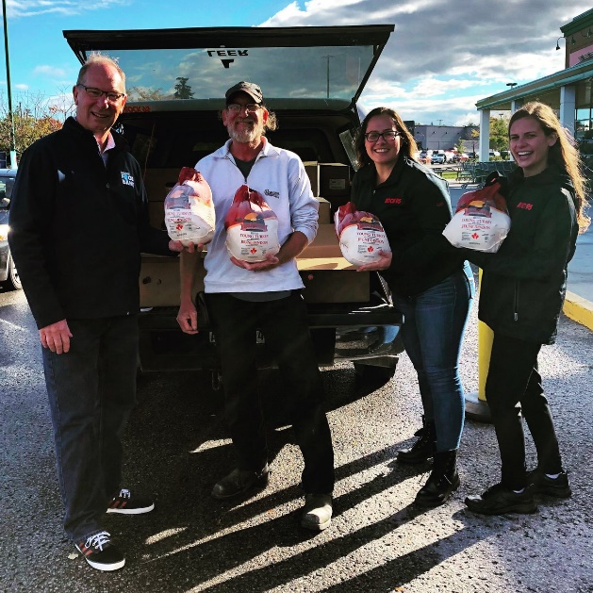This tournament is run in support of **Am Shalom** and **the Barrie Food Bank**. Last year we were able to donate 88 Turkeys to their Thanksgiving Turkey drop.

Please consider this event and show your support by returning the attached form to the synagogue. We would be delighted for you to join us. Your donation is tax deductible.

Once again, thank you for your support.

With best regards,

 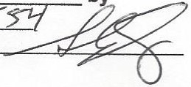

David Shron Stephen Sperling

President Past President

Joel Jacobson and Jeff Koza

Golf Committee Members

**767 Huronia Road, Barrie, Ontario, L4N 9H2 Tel. (705)792-3949**

[**www.amshalom.ca**](http://www.amshalom.ca) **amshalomcongregation@bellnet.ca**

****AM SHALOM CONGREGATION

**SWEET 16TH ANNUAL**

**FUNDRAISING GOLF TOURNAMENT**

**Friday August 16, 2019**

**SPONSORSHIP INFORMATION**

A portion of all proceeds will be donated to the **Barrie Food Bank**.

Monetary Donations are tax deductible. We also welcome any gift/prize/silent auction donations. All sponsors are listed on our website and weekly email.

SPONSORSHIP LEVELS:

**Event Sponsor $5400** - includes full billing for the event, name on all literature, all signage and tickets for a foursome for the day.

**Breakfast or Lunch Sponsor $1800** - donation includes Sponsor Name on literature, signage and tickets for a foursome for the day.

**Golf Carts $1200** - includes signage on all Golf Carts

**Tee Blocks $1200** - includes signage on all Tee Blocks

**Gift Bag Sponsor $900** – includes name on all gift bag items

**Specialty Hole Sponsor $500** - signage on one of the following Specialty Holes: **Putting Contest, Closest to the Pin, Longest Drive, Hole in One**

**Hole Sponsor $180** - includes signage on one Hole

______________________________________________________________

Sponsor Name / Company Name (if applicable)

______________________________________________________________

Address City Postal Code

______________________________________________________________

Phone email

**I wish to sponsor:_______________________for $_____________**

PLAYER INFORMATION

**Innisbrook Golf Course,** 211 Lockhart Rd, Barrie ON

Registration/**Hot** Breakfast 7am, 8am Shot Gun, 1pm Lunch

**Cost $180 per player / $35 for lunch only**

Please email to [amshalomcongregation@bellnet.ca](mailto:amshalomcongregation@bellnet.ca) or mail to Am Shalom 767 Huronia Rd, Barrie ON L4N 9H2

by the **August 2, 2019 Deadline**.

If you register as an individual, you will be placed on a team.

Your $180 Fee includes: Hot breakfast buffet, gift bag, golf cart, shot gun start, silent auction and hot lunch.

MY FOURSOME INCLUDES MYSELF

AND THE FOLLOWING GOLFERS:

1.____________________________________ Vegetarian lunch ___

2.____________________________________ Vegetarian lunch ___

3. ____________________________________ Vegetarian lunch ___

4._____________________________________ Vegetarian lunch ___

Payment:

Total Payable (Sponsorship + Golf fees) $___________

□ Cheque Payable to: Am Shalom Congregation □ VISA □ MASTERCARD

Name on Card: ______________________________________

Card# __________________________ Expiry:______/_______

**Signature**:___________________________________________